
From the East Kingdom Cooks Guild, Field Research Division
By Brunissende Dragonette de Brocéliande, Lêretochter bî Juliana von Altenfeld

Brouet de Savoie

The brouet de Savoie is a hearty and tasty soup. It was served at Bhakail Yules at the end of last year and again for the Athena’s thimble Collegium.
People seemed to like it in both cases, so here it is.

Brouet de Savoie: Le Ménagier De Paris, circa 1393

Page 166 :
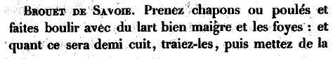
Page 167 :
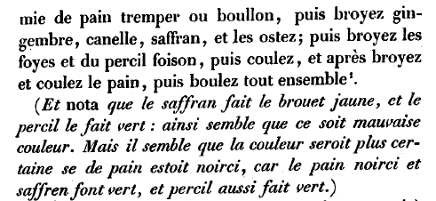

Translation: Take capons or chicken and boil it with very lean bacon and the livers: and when it is half cooked, take it out, then add moistened bread crumbs or stock, then grind ginger, cinnamon, saffron, and take them out; then grind the livers and lots of parsley, then sieve, and then grind and sieve the bread, then boil it all together.
(Note that the saffron makes the soup yellow and the parsley makes it green, so it seems to be a bad color. But it seems that the color would be better if the bread was toasted, as toasted bread and saffron together make green and parsley also makes green.)

Modern recipe:

- chicken broth, 2 liters
- ham, 1 cm thick slice/table
- chicken livers (about 3 pounds total)
- parsley (about 5 bunches total)
- crushed burnt bread as thickener
- ginger, cinnamon, saffron & salt

Concentrated chicken broth was diluted in a big pot. Some broth was used to boil the livers and some to cook the ham. The livers were then taken out the broth and ground with the ham and the washed parsley. All elements were then put back in the initial broth. The bread crumbs were added to thicken the soup. The spices adjusted to taste and the soup was cooked for about 5 more minutes before serving.

Comments:
- Don’t hesitate to add parsley. It really gives a nice greenish color and influence nicely the consistency of the dish. The saffron doesn’t really show much
- This brouet doesn’t really need salt because the ham tend to be salted
- Pepper, cardamom and grains of paradise also go very well in this soup
-------------------------------------------------------------------------------

Useful references:
Le ménagier de Paris :
- in French : http://gallica.bnf.fr/scripts/ConsultationTout.exe?E=0&O=N083111
- translated: http://www.daviddfriedman.com/Medieval/Cookbooks/Menagier/

East Kingdom Cooks Guild discussion group:
http://groups.yahoo.com/group/EKCooksGuild/

--------------------------------------------------------------------------------

