
From the East Kingdom Cooks Guild, Field Research Division
By Brunissende Dragonette de Brocéliande, Lêretochter bî Juliana von Altenfeld

De gustibus coloribus – II

Last month we described 2 recipes, for 3 colors: white, green and black. This time the recipes described are more in the tawny tones. It’s only two recipes, very simple, but they have many variations. The original texts are, as indicated, from Le Ménagier De Paris. As previously, there is almost no indication of the volumes to be used. So, again the rule applies: adjust to taste.

Mustard sauce

Moutarde: Le Ménagier De Paris, circa 1393
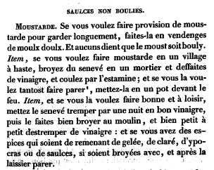
Translation: Mustard. If you wish to store mustard to be kept for a long time, do it at wine-harvest in sweet must. And some say that the must must be boiled. Item, if you want to make mustard in a village hastily, grind some mustard-seed in a mortar and soak in vinegar, and strain; and if you want to make it ready faster, put it in a pot in front of the fire. Item, and if you wish to make it well and at leisure, put the mustard-seed to soak overnight in good vinegar, then have it ground fine in a mill, and then little by little moisten it with vinegar: and if you have some spices left over from making aspic, broth, hypocras or sauces, they may be ground up with it, and then leave it until it is ready..

An even simpler version with the modern redaction by Pani Jadwiga Zajaczkowa: Brown Mustard from Rumpolt
http://gallowglass.org/jadwiga/SCA/cooking/recipes/brownmustard.html
Marx Rumpolt, Ein New Kochbuch, c. 1581:Brown Mustard Sauce

Brown mustard made up with clear vinegar/ is also good.
1-2 cups mustard seed
3-4 cups white wine vinegar

1. Grind the mustard seed to get 2-3 cups ground brown mustard
2. The day before the feast, mix with white wine vinegar to make a running sauce.

Much more about mustard sauce can be found on that site (Pani Jadwiga Zajaczkowa again) http://www.gallowglass.org/jadwiga/herbs/Mustards.html
A personal remark, once your mustard is ready, if it’s too thick, it is still possible to adjust the consistency by adding vinegar. Alternatively, if it’s too liquid you can add ground/powdered mustard to make it thicker.

Cameline

Cameline: Le Ménagier De Paris, circa 1393
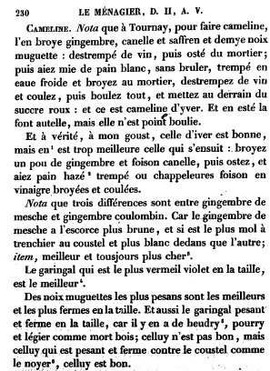
Translation: Cameline. Note that at Tournay, to make cameline, one grinds ginger, cinnamon and saffron and half a nutmeg: soaked with wine, then taken out of the mortar; then have white breadcrumbs, not burnt, dampened with cold water and grind in the mortar, soak in wine and strain, then boil it all, and lastly add red sugar: and this is winter cameline. And in summer they make it similarly, but it is not boiled.
And in truth, for my taste, the winter sort is good, but the following is much better: grind a little ginger with lots of cinnamon, then take it out, and have lots of soaked toasted bread or bread-crumbs in vinegar, ground and strained.
Note that three differences exist between “gingembre de Mesche” (Rq: transited via Mecca) and “gingembre coulombin” (Rq: from he Madras area). For “gingembre de Mesche” has a darker skin, and is softer to cut and whiter inside than the other; item, better and always more expensive.
Galingale which is most reddish-violet when cut is the best.
The heaviest nutmegs are the best and the firmest to cutting. And also the heavy galingale which is firm in cutting, for if it is spoiled it is rotten and lightweight like dead wood; this is not good, but that which is heavy and firm under the knife like walnut-wood, that is good.

Modern redaction by Pani Jadwiga Zajaczkowa: Tournai-style Cameline sauce
http://gallowglass.org/jadwiga/SCA/cooking/recipes/cameline.html

- 5 slices bread
- 2 nutmegs
- 25-35 threads saffron
- 2 tbsp ground ginger
- 3 tbsp cinnamon
- 7 1/2 c. white wine
- 1 1/2 c brown (turbinado) sugar

Grate your nutmeg into the mortar. Add cinnamon and saffron and grind together with ginger. Add the white wine. Strain, then bring to a boil and add sugar. Cook until thin sauce consistency.

Sum, ergo edo: to be continued…

--------------------------------------------------------------------------------

Other useful references:
Le ménagier de Paris :
- in French : http://gallica.bnf.fr/scripts/ConsultationTout.exe?E=0&O=N083111
- translated: http://www.daviddfriedman.com/Medieval/Cookbooks/Menagier/

East Kingdom Cooks Guild discussion group:
http://groups.yahoo.com/group/EKCooksGuild/

Jadwiga's Recipes: http://gallowglass.org/jadwiga/SCA/cooking/recipes/recipes.html

