
From the East Kingdom Cooks Guild, Field Research Division
By Brunissende Dragonette de Brocéliande, Lêretochter bî Juliana von Altenfeld

De gustibus coloribus

If the taste of the food is the more important when cooking, the aspect of the dish is decisive for making it appetizing. A way to play with the visual aspect is to use a nice combination of colors. Below are some easy recipes from Le Ménagier De Paris with different tastes and different colors. They also belong to two different categories: boiled (black) or non-boiled (white or green) sauce.
Often the original recipe does not give any indication about volumes. Remember there is but one rule: adjust to taste

White or green garlic sauce for goose or beef

Saulce d’aulx blanche ou verte pour oisons ou beuf: Le Ménagier De Paris, circa 1393
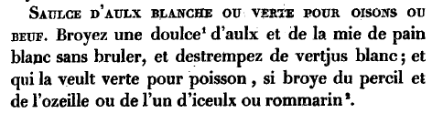
Translation: Grind a clove of garlic and white non-burnt breadcrumbs, and saturate with white verjuice; and who wants it green for fish, grind in some parsley and sorrel or one of these or rosemary.

Modern recipe: the green sauce
What I have been using is very simple: in a chopper put a bunch of washed parsley (only the small groups of leaves), add about 7 cloves of garlic (without the germ), a table spoon of breadcrumbs (fresh or dry is OK) and about ¼ of cup of verjuice substitute. Grind, add liquid if necessary until you like the texture. I like to add some rosemary, pepper, ginger and cardamom.

Notes on the recipe:
The green sauce is simply the white sauce where you add something bringing additional taste and the green color.
The recipe itself is very simple: grind and mix. However, two problems exist: one of the ingredients, the verjuice, is not easily available; and there is real no indication of the amounts to use.
The verjuice can be found seasonally in some gourmet food stores or purchased via the Pepperer’s guild (http://members.cox.net/periac/pepperers.html). But if you can’t find it, it is possible to use a substitution such as 2 parts grape juice, 1 part dry red wine, and 1 part wine vinegar. It is supposed to be the juice of unripe grapes (or other fruits) so it has to be on the acidic side. A touch of lemon juice can also help. Another variant of verjuice is supposed to be obtained from sour apples. In that case, a good substitution is obtained by mixing apple juice and apple cider vinegar
Now for the problem of lack on indication, remember the rule: adjust to taste.
For people worried about carbohydrates, you can actually do exactly the same recipe without the breadcrumbs. That makes it low fat, low carbs, awfully healthy and terribly tasty.

Black: black pepper sauce

Poivre noir: Le Ménagier De Paris, circa 1393
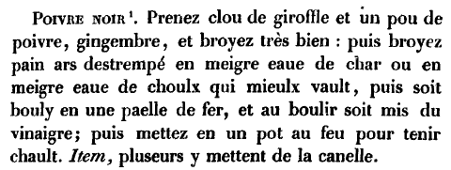
Translation: Take a clove and a little pepper, ginger, and grind very thinly: then grind burnt bread soaked in meat broth or in cabbage broth which is better, then boil in an iron pan, and when boiling add vinegar; then put in a pot on the fire to keep warm. Item, some add cinnamon.

Notes on the recipe: Again the recipe is very simple but it involves a boiling step.
The black color is mostly due to the burnt bread but could possibly also be influenced by the type of pan. It is probably better to use an iron or a regular non-stick pan.
This sauce can be stored longer than the white/green sauce. To be on the safe side, store them in the fridge, but in both cases I’ve never seen any of them have the time to go bad go bad ;)
--------------------------------------------------------------------------------

Useful references:
Le ménagier de Paris :
- in French : http://gallica.bnf.fr/scripts/ConsultationTout.exe?E=0&O=N083111
- translated: http://www.daviddfriedman.com/Medieval/Cookbooks/Menagier/

East Kingdom Cooks Guild discussion group:
http://groups.yahoo.com/group/EKCooksGuild/

--------------------------------------------------------------------------------

And now, a poetic interlude…
Green sauce
(not written by Henry VIII)

Alas my cook, you do me strong
Add the garlic so generously
And chop parsley and herbs along
Delighting verjuice company

Chorus:

The green sauce was all my joy
The green sauce was my delight
The green sauce for a heart of gold
And what but a cook’s green sauce?

Chorus:

I have been ready at your hand
To cover whatever you would crave.
With a wood spoon akin to a wand
Mixed all the ingredients you have

Chorus

You poured some green sauce on boar’s head
That was baked fine and gallantly.
You kept me at dayboard and bed,
Which marked your breath inauspiciously.

Chorus
Your men were covered all with green,
And they did ever wait on me;
All this was gallant to be seen,
And yet some wouldst not love me.
Chorus
Ah, green sauce, I say farewell, adieu,
To cooks I pray to remember me,
For I am still thy lover true,
Prepare me again and love me.

http://www.uidaho.edu/student_orgs/arthurian_legend/game/music/GreensleevesLyrics.htm

